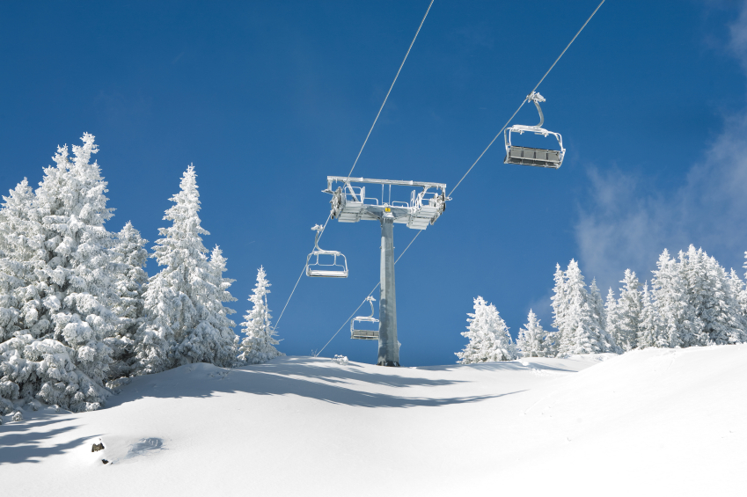
Potomac Valley Skiers

Trip Details
Once again, we will be staying at the Snowmass Mountain Chalet (SMC) which offers a convenient ski in, ski out location. The “LAND ONLY” package includes: transportation to and from Aspen airport; 5- day Senior (65 and older) lift pass (good for all four ski areas in the Aspen complex, free shuttle bus); 7 nights lodging (double occupancy); luggage handling; buffet breakfast, soup lunch, welcome reception, pizza party and farewell group dinner to celebrate our trip. Additional nights at Snowmass are an option based on availability.
Trip insurance is available through www.Encompasse.com and is highly recommended.

The Basic Package price is based on 2 people per room. We have 20 rooms reserved consisting of Standard and Deluxe, King and Queen/Queen rooms. The Standard Rooms are on the 1st floor/ground level with no microwaves or coffee makers. Deluxe Rooms are on floors 2-4. See below for pricing. Room preferences will be on a first come first serve basis.

Costs: Standard Deluxe
Basic Land Only Package (65 and older) $2,336 $2,506 per person
Under 65 add $ 130 $ 130
Single Supplement add $1,605 $1,775
Extra hotel night (pending availability) add $ 419 $ 453 per room per night
Non-skiers deduct $ 396 $ 396
2025 SNOWMASS, Colorado Ski Trip

Wednesday - Wednesday
January 8 – 15, 2025
Extra ski days (65 and older) add $ 119 $ 119 6 day Senior pass
add $ 199 $ 199 7 day Senior pass
Under 65 add $ 247 $ 247 6 day pass
Silver Pass (Age 70 and older) add $ 353 $ 353

Payment Schedule
Deposit of $1,250 due by July 10th with Application & Signed Waiver
Final payment due September 1st

Checks should be made out to Kathy Lake and mailed to
11677 Fox Glen Drive, Oakton VA 22124
(put PVS Snowmass 2025 on the check memo line).

Cancellation Policy: The entire cost of the trip is non-refundable after September 27th.

Kathy & Barry Lake are the trip leaders. Feel free to contact us at 703-625-2715 or kathylakehomes@yahoo.com

APPLICATION FORM
Potomac Valley Skiers Trip to Snowmass, Colorado January 8-15, 2025

Name (List both names if a couple) as on your Official ID:

___________________________________________________________Age 65 or older Y N

___________________________________________________________Age 65 or older Y N

Address:____________________________________________________________________________

____________________________________________________________________________________

Home phone: __________________________ Cell phone: _________________________________

Email: ______________________________________________________________________________

Emergency Contact and Phone:______________________________________________________________________________
NOTE: Please let trip leader know of any special medical issues which may affect your trip.

Roommate (if a separate person) - Official name as on ID: __________________________________

Bedding Preference (Pending Availability): ____ 1 King or ____ 2 Queens _____Deluxe or _____Standard

Standard Deluxe Price
Basic Snowmass Package (65 and older) $2,336 $2,506 per person
Under 65 add $ 130 $ 130
Single Supplement add $1,605 $ 1,775
Extra hotel night (Pending Availability) add $ 419 $ 453 per room/night
Non-skiers deduct $ 396 $ 396
Extra ski days (65 and older) add $ 119 $ 119 6 day Senior
add $ 199 $ 199 7 day Senior
Under 65 add $ 247 $ 247 6 day pass
Silver Pass (70 & older skiing 8 or more days) add $ 353 $ 353

Please check all appropriate spaces: Cost (will be filled in by trip leader):

____ Basic package _________________

____ Single supplement _________________

____ Extra hotel nights _________________

____ Non-skier _________________

____ Extra day(s) of skiing ____days _________________

____ Silver pass _________________

Total price of trip $________________

Additional nights at SMC: yes____ no_______ if yes, what dates? ___________________________

Additional comments _________________________________________________________________

WAIVER
.

RELEASE, ASSUMPTION OF RISK, AND WAIVER OF LIABILITY AGREEMENT PERTAINING TO THE JANUARY 8-15, 2025 SKI TRIP to SNOWMASS, COLORADO (Potomac Valley Skiers)

- I acknowledge that there are inherent risks in the sport of skiing and other sports or activities in which I might participate during this trip, and in the process of traveling. There may be bodily injury, illness, accident, death, property loss or damage, and unanticipated additional costs or other economic losses. I fully and willingly accept the responsibility and liability for all such risks, dangers, costs, and losses.

- I agree not to sue or hold responsible the trip leader, Potomac Valley Skiers, Inc. (hereafter PVS), its officers and members of the Executive Committee, or its members for: (1) any accident, personal injury, illness, or death occurring to me or to any other trip participant, arising directly or indirectly from this trip; (2) any loss of deposit of payment, any other property or economic loss, or unanticipated additional costs, delay, or change of itinerary arising out of any action or inaction of any hotel, airline, tour operator, land transportation operator, or other entity or person providing services on this trip; and (3) any trip cancellation, delay, early termination or extension due to acts of God, forces of nature, or other force majeure events or situations. I willingly and with full knowledge assume these risks.

- I understand and agree that the trip leaders, and the tour operators or agents with whom the trip leaders have contracted, have the right to substitute accommodations of similar or better quality, to change transportation arrangements and providers, and to modify other services. In the event of such changes, no refund or credit will be provided if the accommodations, transportation, or services are of comparable or better quality and cover the same approximate time period.

- I agree that I am not entitled to a credit or refund for any included trip service that is not used by me.

I have read and I fully understand this “Release, Assumption of Risk, and Waiver of Liability Agreement,” the final trip flyer, and the trip application, and I agree to all of the specified terms and conditions.

Signature of Participant:________________________________________Date:__________

Printed Name of Participant:________________________________________

Signature of Participant:________________________________________Date:__________

Printed Name of Participant:________________________________________

